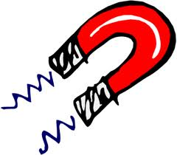

Name: ____________________________________________

Class: _____________________________________________
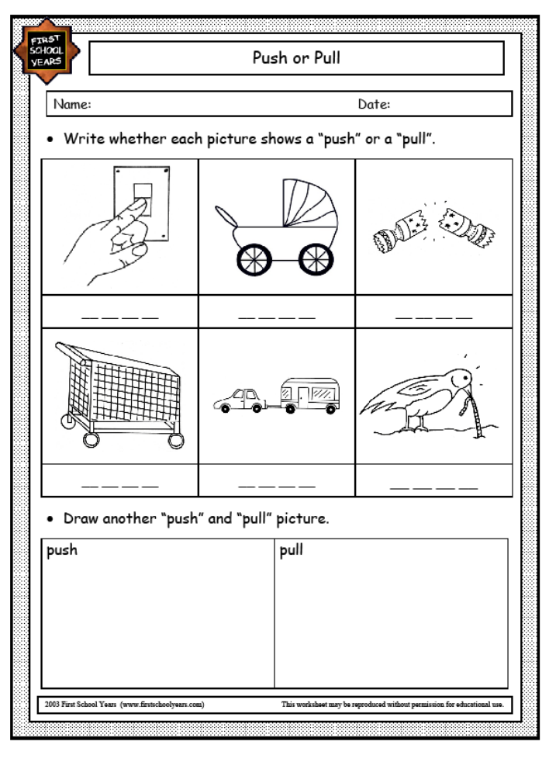

FORCES AROUND YOU

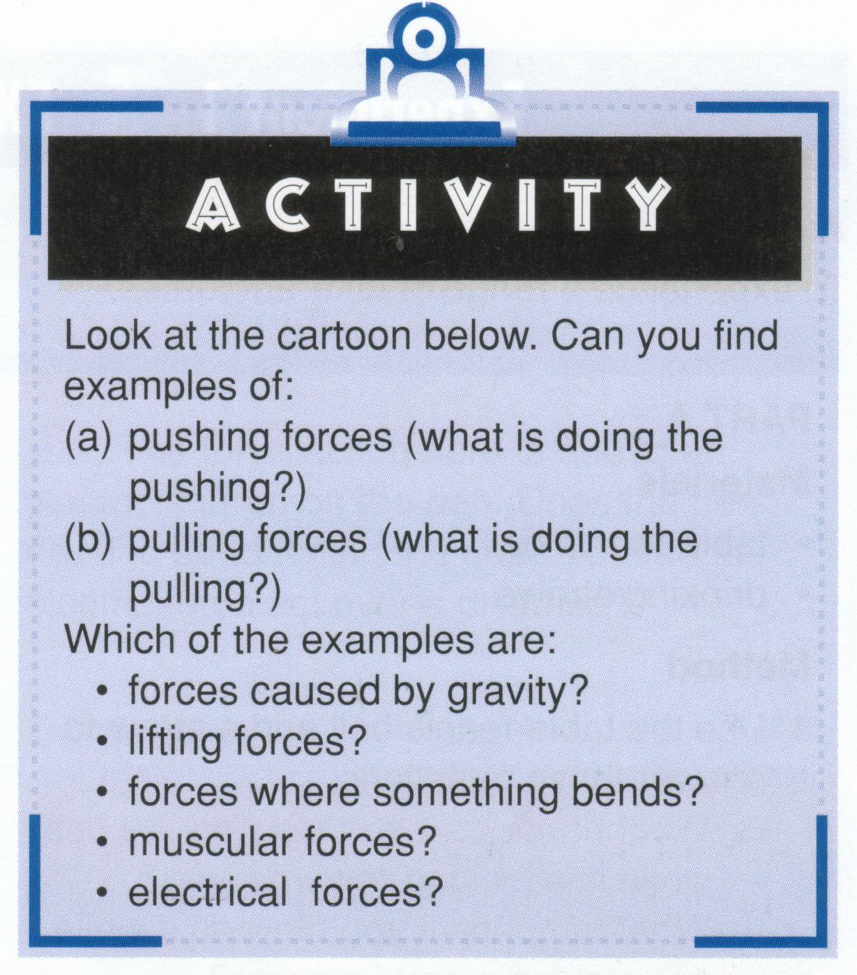
Forces are pushes or pulls. They can start objects moving, and they can stop, speed up, slow
down, or change the direction of moving
objects. They can lift things, or cause them
to turn, bend, or twist. They can also prevent
motion: for example, they can stop a
bridge from collapsing.

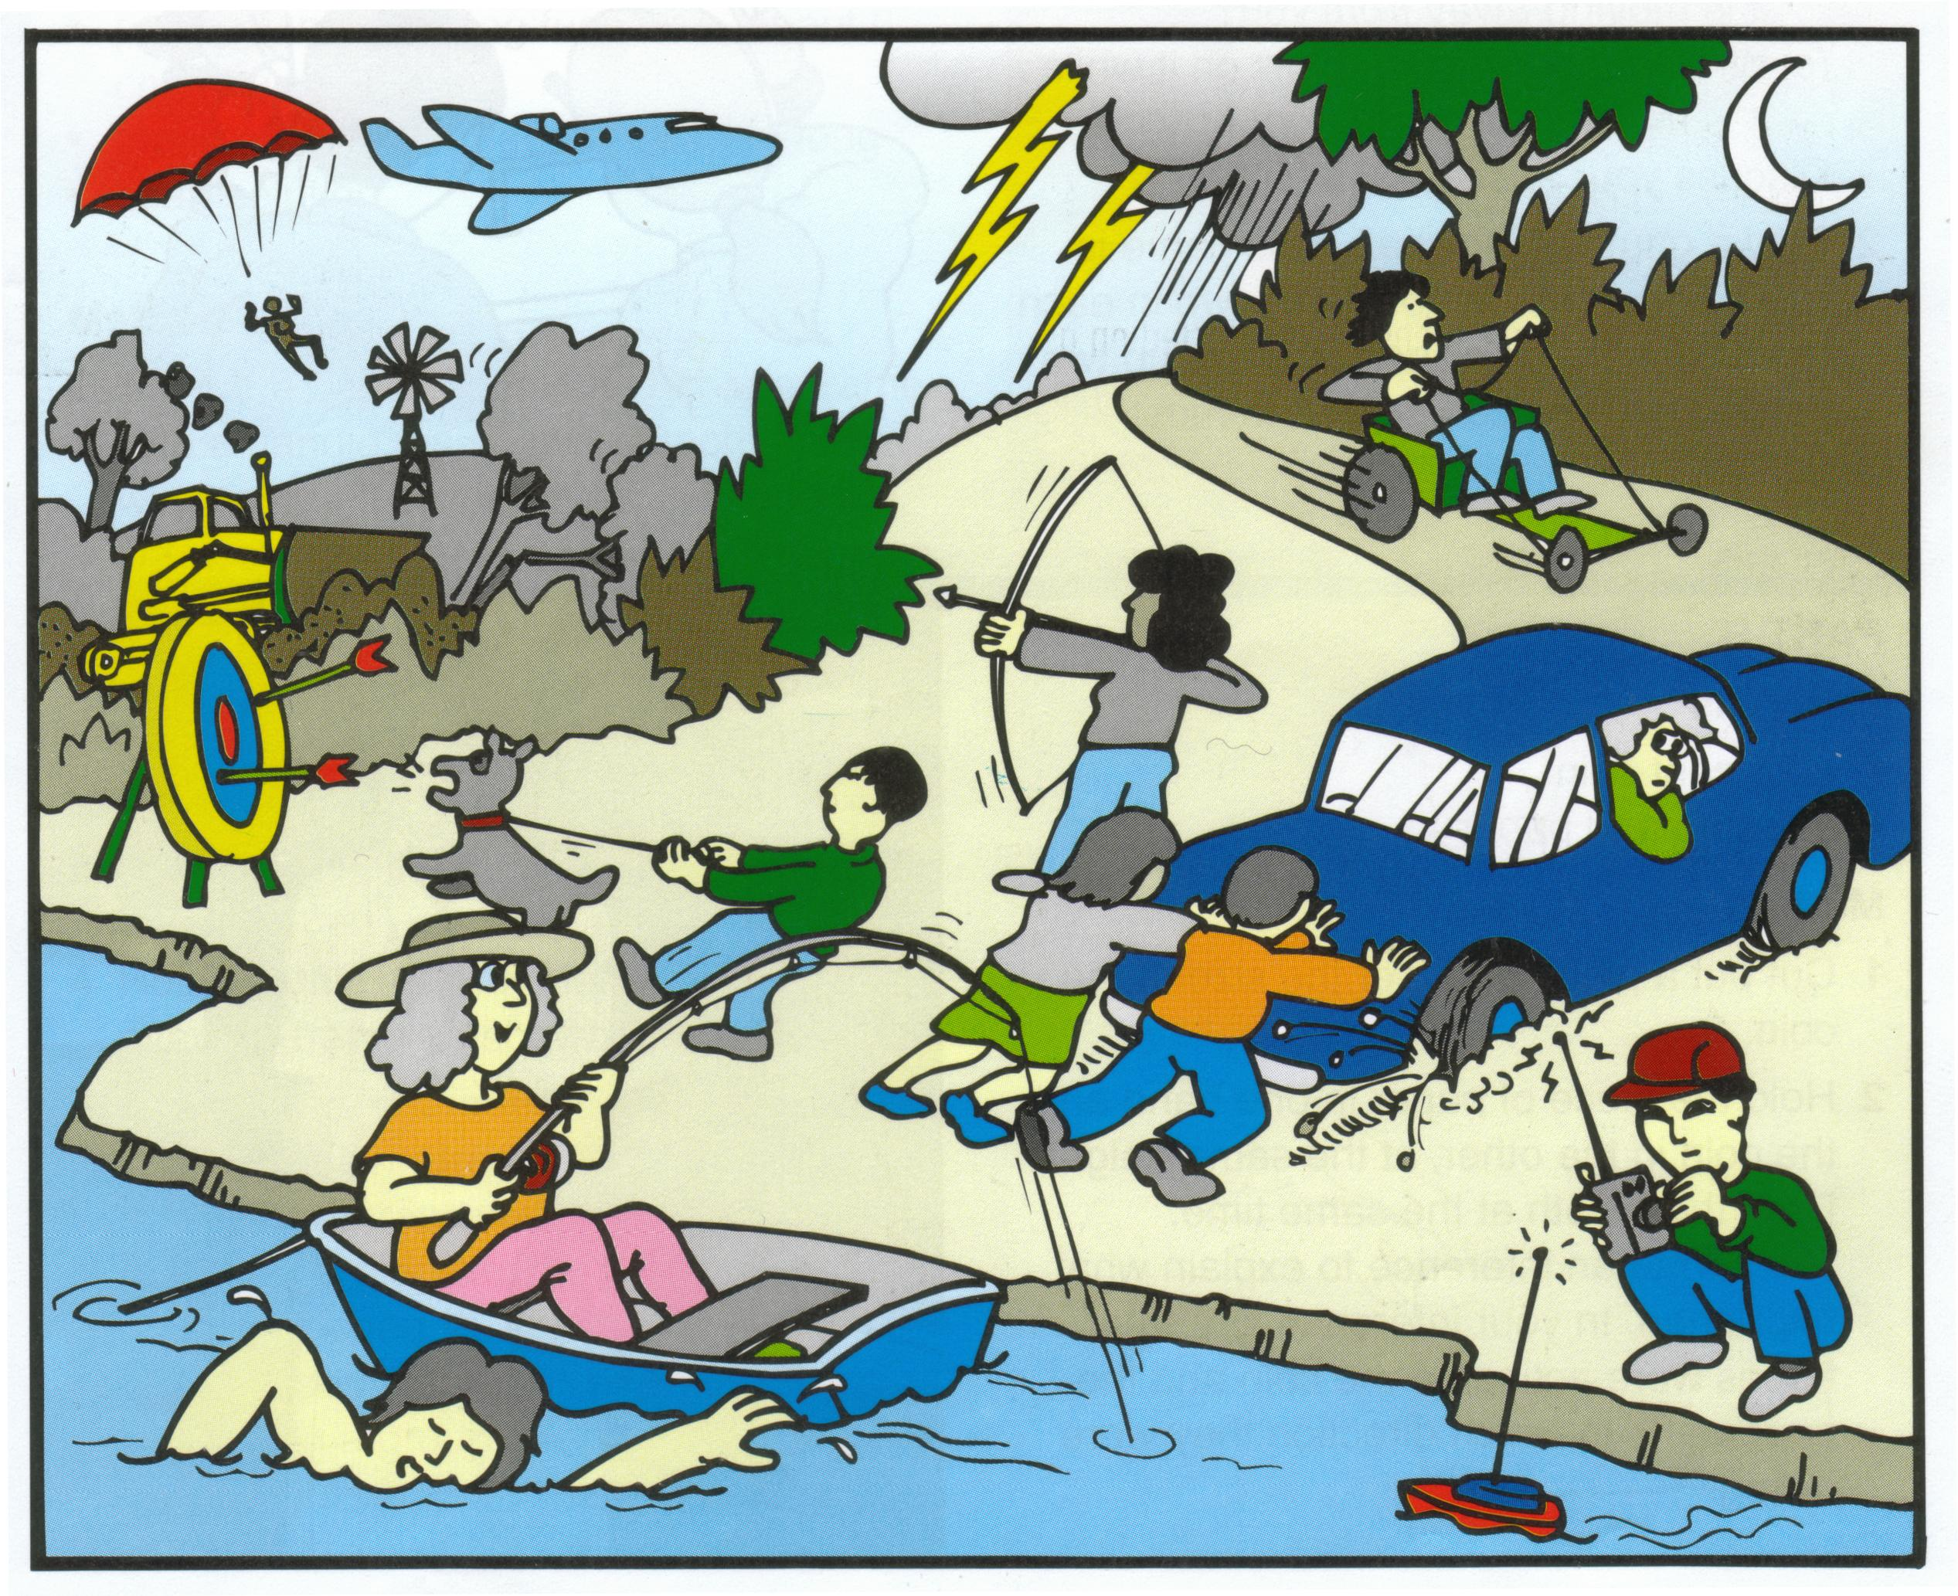

From the image on the previous page list all forces, decide if they are a push, pull or twist and what type of force is causing the motion.

Description of force | Push, pull or twist | Type of force

Forces are pushes or pulls which can change the shape or motion of an object.

The only way to describe forces is by describing what they do.

Draw up the following table. The first example of an effect a force is given. In class discussion, students give examples of various effects of forces. They complete the table.

Effect of Force | Example
Starting Motion | 1)  2)  3) | Kicking a stationary ball.
Stopping Motion | 1)  2)  3 | Catching a moving basketball.
Speeding up Motion | 1)  2)  3 | Kicking a ball in the same direction it is moving.
Slowing down Motion | 1)  2)  3 | Space capsule uses a parachute to slow down.
Changing Direction of Motion | 1)  2)  3 | A soccer ball is kicked in the opposite direction it is moving.
Changing the Shape of an Object | 1)  2)  3 | Squeeze toothpaste.
Having No Visible Effect | 1)  2)  3 | A standing building.

1 Match the descriptions with the pictures and choose the correct word or words.

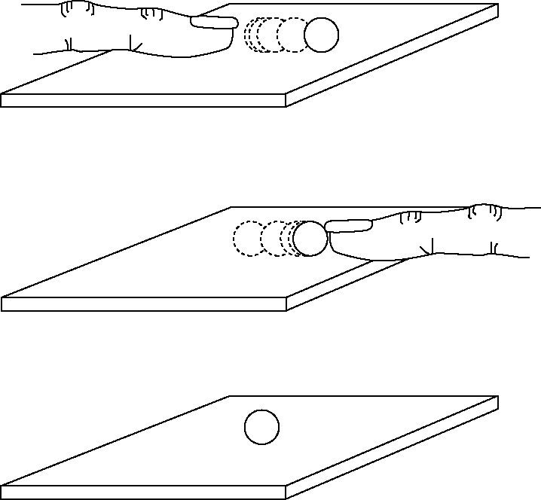 | When the ball is resting on the  table top, the forces are  unbalanced/balanced.
The ball will move if you push it
because the forces are
unbalanced/balanced. If you stop
pushing it, it will slow
down/speed up because
of the friction between it and your
hand/the table top. If you keep
pushing it, it will slow down/keep
moving. If you push it harder, it
will move slower/faster.
If you push a rolling ball in the
opposite direction to its motion, it
will speed up/slow down. If you
apply a push at an angle to its
motion, it might change
direction/speed/direction and
speed.

2 Choose words from the box to complete the sentences.

energy friction average pull time start speed stopped

Force is the general name for a push, a ____________________ or a twist.

Forces can ____________________ , stop or change the direction of an object.

Forces give ____________________ to objects.

____________________ is a force that tries to stop things moving.

Motion cannot be started, altered or ____________________ except by a force.

One way to compare motion is to compare the ____________________ of objects.

Speed is the distance an object travels in a certain amount of ____________________ .

When we divide the distance travelled by the time taken, it gives us the ____________________ speed.
Pushing and pulling forces
Key terms
gravity unbalanced forces
• Forces are pushes or pulls.
• Forces can change the speed of something or change the direction of its movement.
• Force can also change the shape of something.
• Force is measured in units called newtons (N).
• Force can be measured using a spring balance or an electronic force sensor.
Forces only cause movement when the force is bigger in one direction, when the forces are unbalanced. Look at your books on the table. They are not moving but there are forces acting on them. Gravity is pulling the books downwards and the table is pushing the books back up with the same force. The forces on the books are balancing each other out and the books do not move.
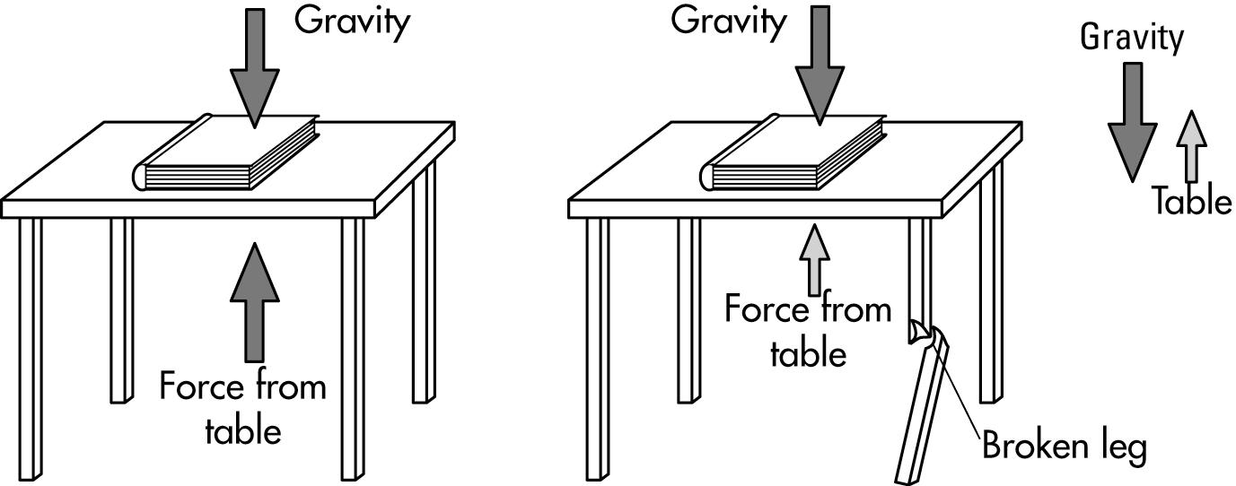
If the leg of the table breaks, the force of gravity will pull the books downwards. The books move down because the force pulling down is bigger than the force of the table pushing upwards. The two forces combined result in an overall downward force. This force is called the net force.

No net force Net force downwards
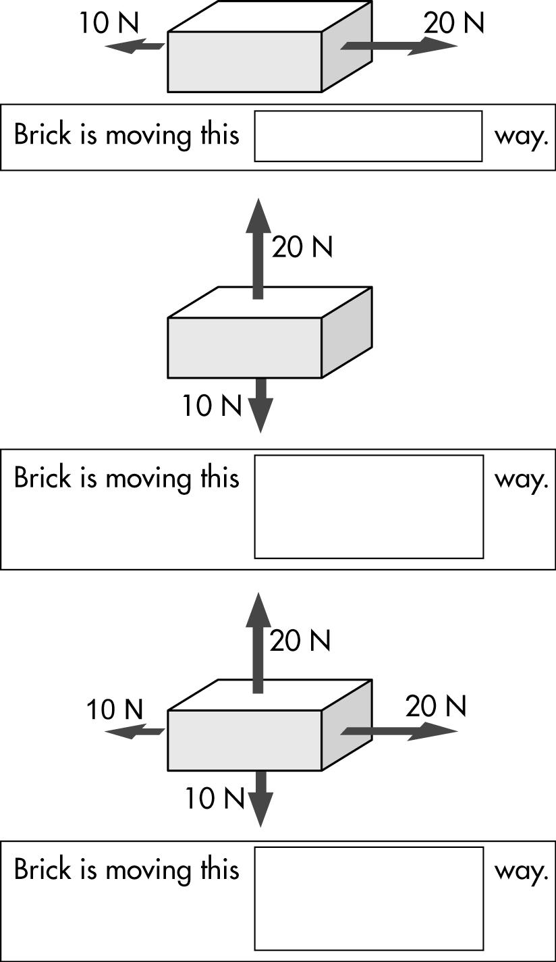
Label the net forces below and draw an arrow that shows in which direction the object is moving.

Rule a line to match each statement with the correct term. (Start the lines from the dots.)
The letter that the line passes through gives the answer to the question at the bottom of the page.

1 The movement of an object.  C  A  L  E  C  A  T  E  R  E |  | weight
2 The measure of the force of gravity on an object. |  | upthrust
3 The distance an object travels divided by the time. |  | unbalanced
4 The unit for measuring force. |  | motion
5 The upward force on an object due to the water it has displaced. |  | newton
6 The amount of material in an object. |  | speed
7 The rubbing force that opposes motion. |  | gravity
8 Motion is started, altered or stopped when forces are ___. |  | kilogram
9 The unit for measuring mass. |  | friction
10 The force of attraction between the Earth and an object. |  | mass

Pedalling your bicycle harder causes it to go faster or …

1___ 2___ 3___ 4___ 5___ 6___ 7___ 8___ 9___ 10___

Friction in Everyday Life

We use friction everyday. Sometimes we need friction, and at other times we try to reduce it.
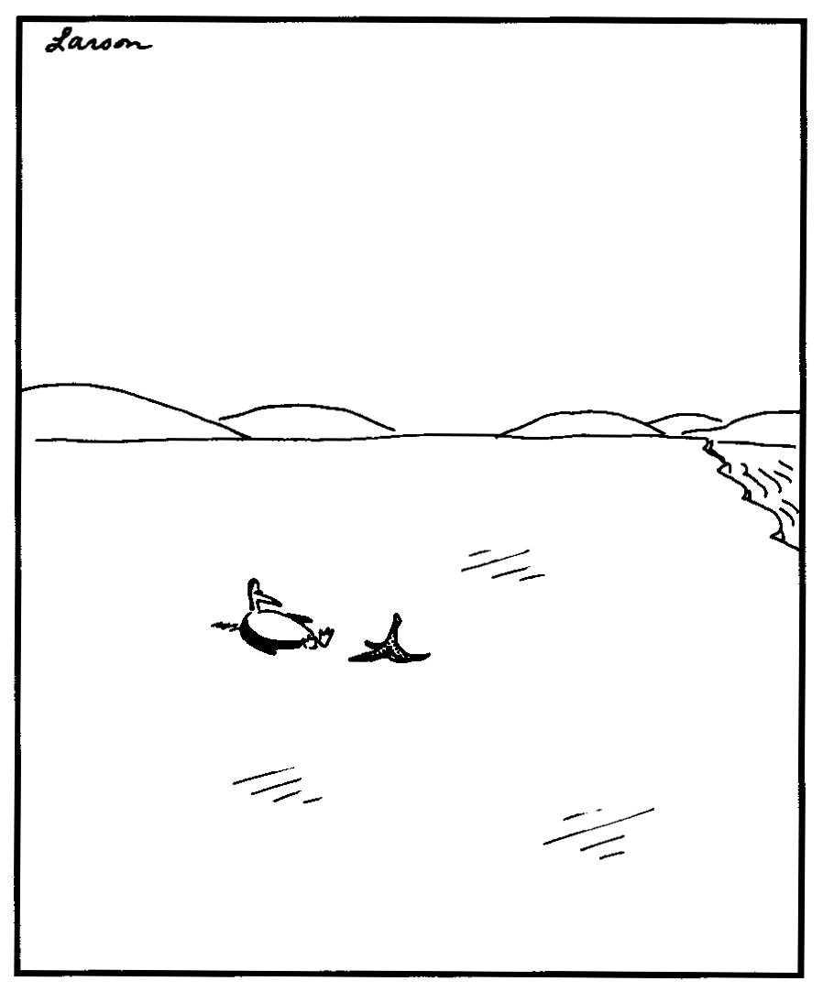
Need friction? We need it for example when:
- we walk. We use the friction between our feet and the ground. Imagine trying to walk if there was no friction. This would be like walking on ice!
- we drive a car. You could not stop a car without friction. You could not start it moving either – the wheels would just spin without the car moving. And everybody knows what happens if you go too fast around a corner or if the road is slippery.
- we use knots or nails. Friction stops knots from coming undone, and holds nails in place.
The list goes on and on.

However, friction can also be a hassle. It opposes motion as we have already mentioned. Friction also produces heat. This can be useful when you rub a match on the side of a box, but it can also cause an engine to overheat. Friction also causes wear and tear.
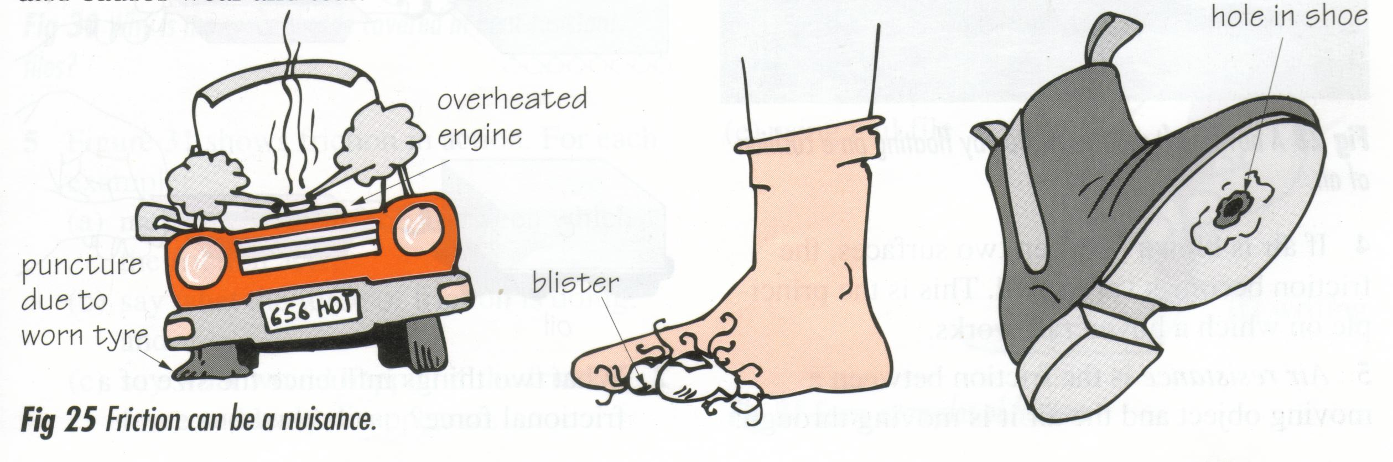

Friction can be a nuisance.

Reducing Friction
There are five different ways of reducing friction.
- A rolling object meets with less friction than a sliding one. (eg: moving a car on wheels, Egyptions moving huge blocks on rolling logs, ball bearings).
- Lubricants (LOO-bri-cants) such as oil and grease are often used to reduce friction between moving parts to reduce wear and tear and make them slide more easily (eg: in machines, on the bearings in bicycle and skate board wheels, between bones in our joints).
- Surfaces in contact can be polished so that they slide over one another more easily. (eg: hulls in racing yachts).
- If air is blown between two surfaces, the friction becomes very small. This is the principle on which a hovercraft works.
- Air resistance is the friction between a moving object and the air it is moving through, and can be reduced by giving the object (eg: car, plane) a more streamlined shape. Streamlining is also important for objects moving through water (eg: surfboards, speedboats and fast-swimming fish).

Questions
- Give two examples of how we need friction, and of how friction can be a nuisance.

- Use your knowledge of friction to briefly explain the following:
- Gymnasts put rosin on their hands before competing.

- Surfers wax their surfboards.

- A car uses more petrol when fitted with a roof rack.

- When you drive your car down a long steep slope the brakes become quite hot.

- Look at the adjacent diagrams. Copy and complete the sentences below using the correct words.
- Diagram A shows _________ (rolling/sliding) friction.
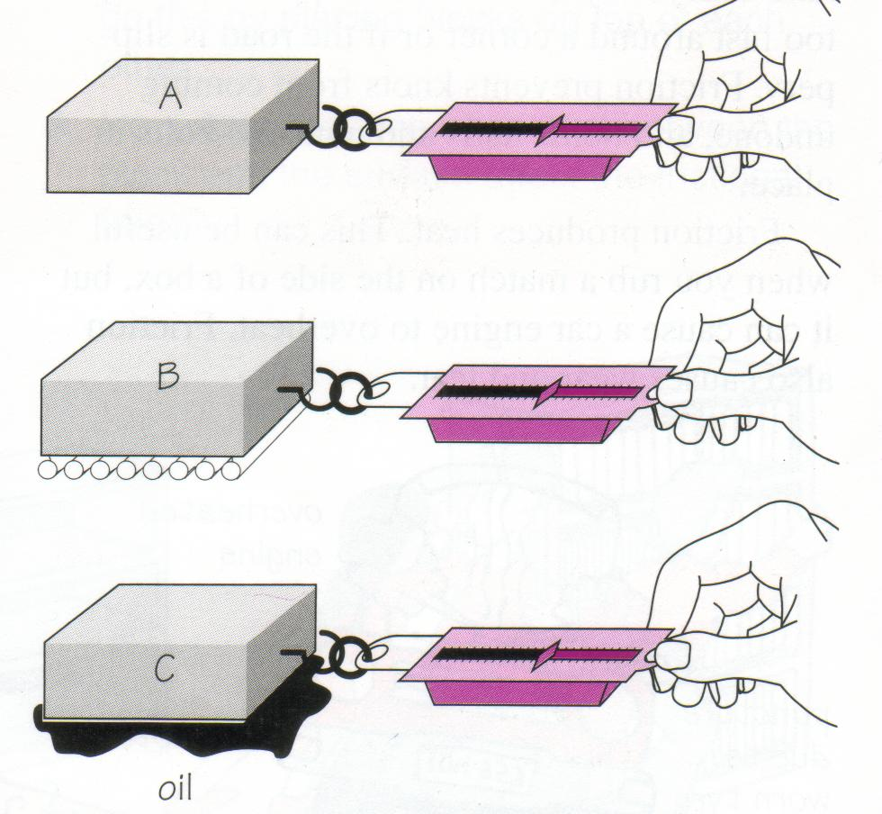
- The friction in B is ___________ (greater/less) than
in A.
- Rolling friction is __________ (greater/less) than
- sliding friction.
- When the object slides there is __________ (more/less) resistance to movement than when it rolls.
- With lubrication (diagram C) you need __________ (more/less) force to move an object.
- Lubrication __________ (increases/decreases) friction.

- Link each of the following with how friction is reduced.

roller skates
concorde (fast airplane)
door hinge
bob sled
lubrication
polishing
ball-bearings
streamlining

5. The figures below show friction in action. For each example:
- name the two surfaces between which the friction acts
- say what the force of friction is doing, and
- say what would happen if the friction force suddenly disappeared.

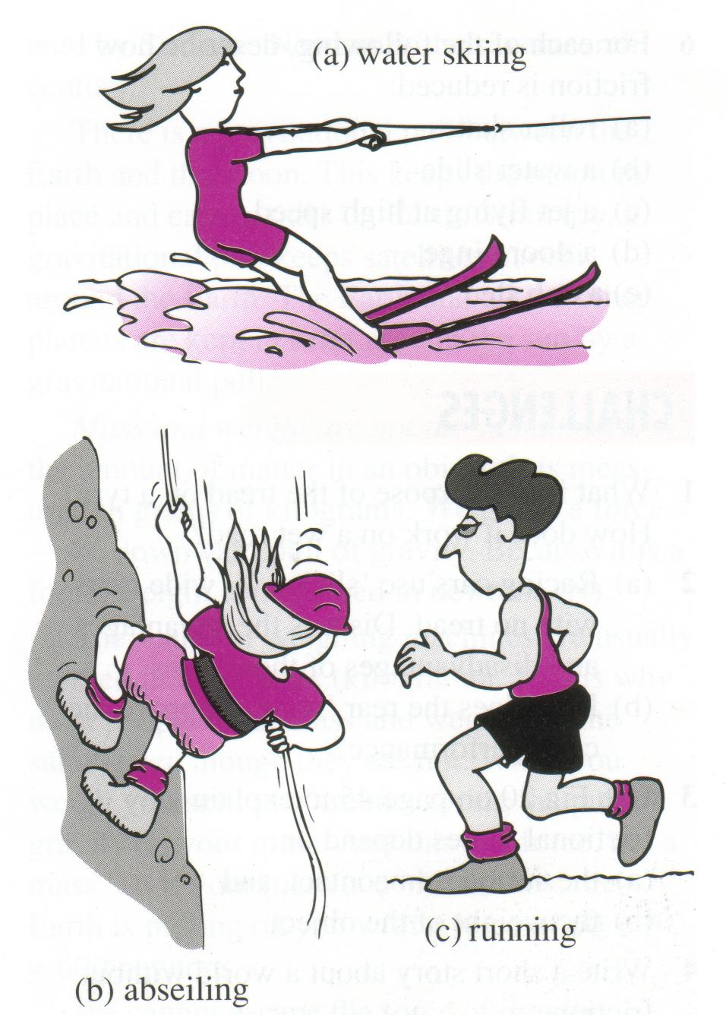
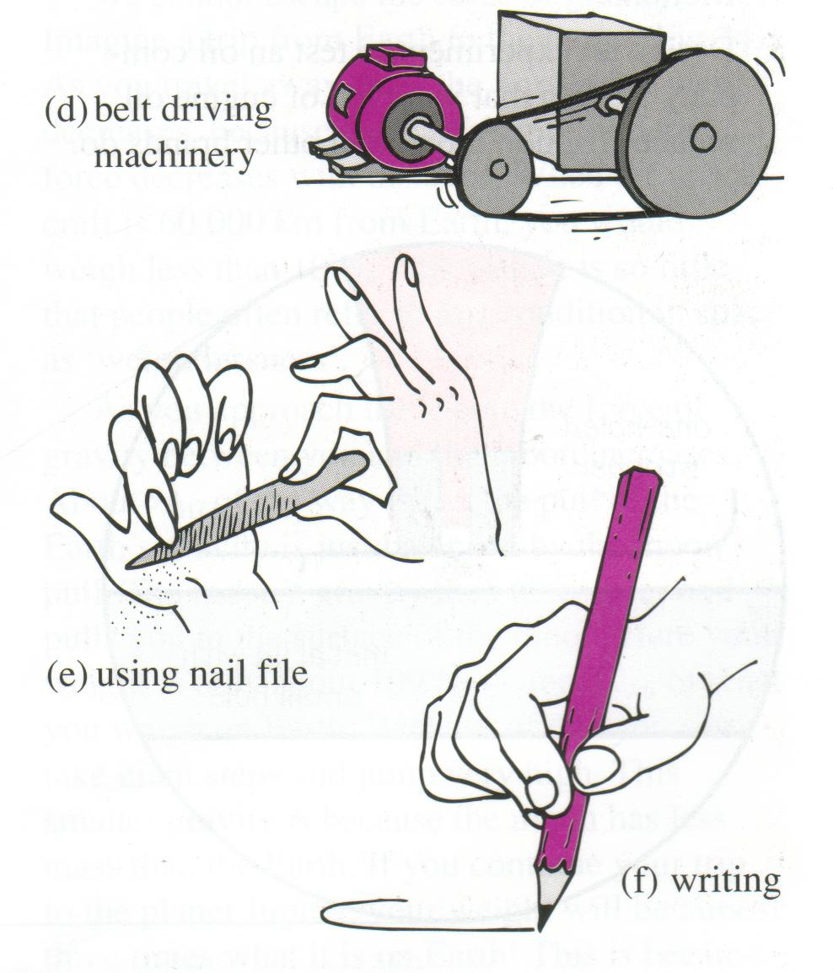

WATER SKIING
The two surfaces between which the friction acts are

The force of friction is..
If the friction force suddenly disappeared then

ABSEILING
The two surfaces between which the friction acts are

The force of friction is..
If the friction force suddenly disappeared then

RUNNING
The two surfaces between which the friction acts are

The force of friction is..
If the friction force suddenly disappeared then

USING A NAIL FILE
The two surfaces between which the friction acts are

The force of friction is..
If the friction force suddenly disappeared then

FORCES IN ACTION
The diagrams below show some forces in action. The forces are shown with arrows. For each picture:
- Name the object that the force acts on; for example, in A the force acts on the ball.
- Choose from the list below what the force is doing in each case.
- starting an object moving
- stopping an object that is moving
- changing the direction of movement
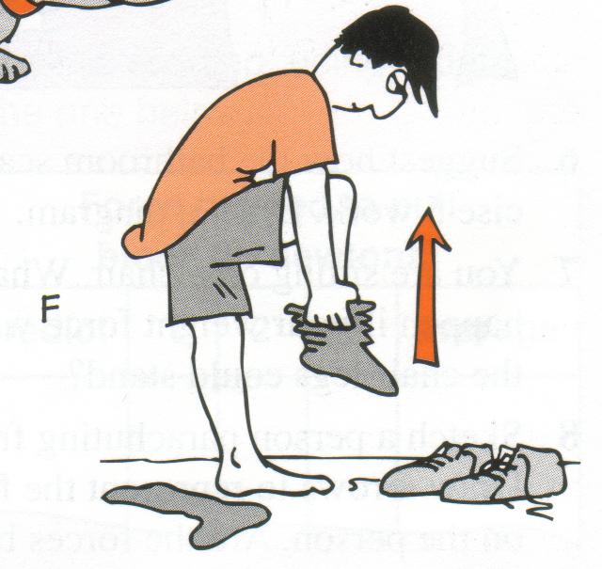
- bending a object
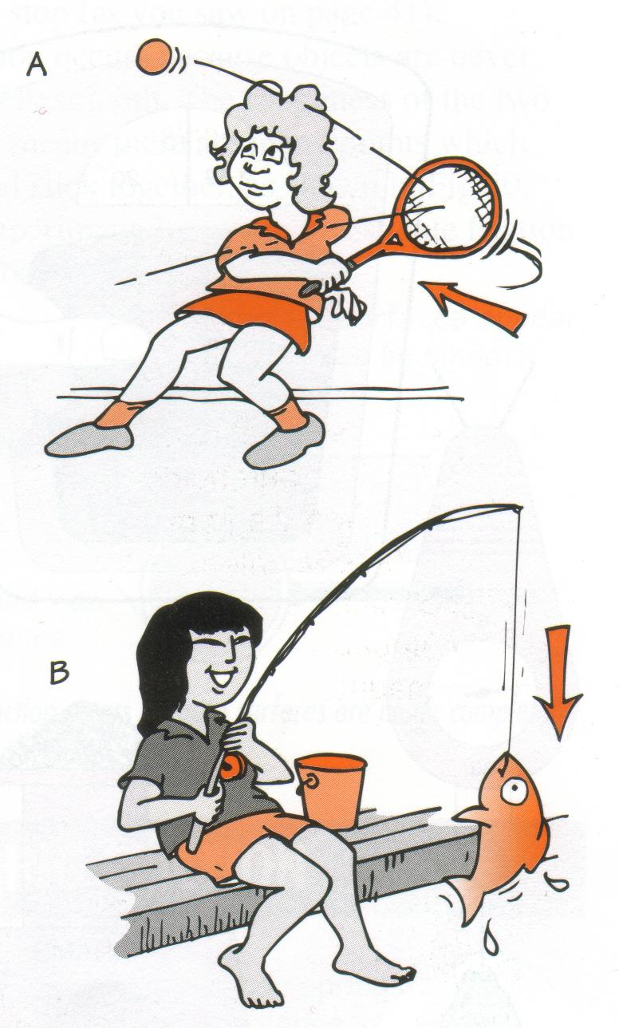
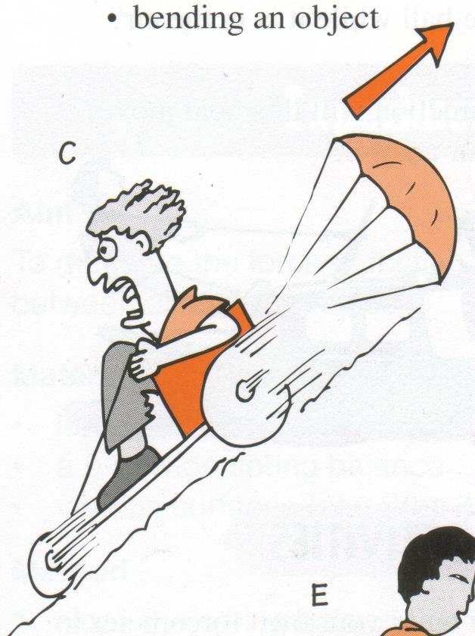

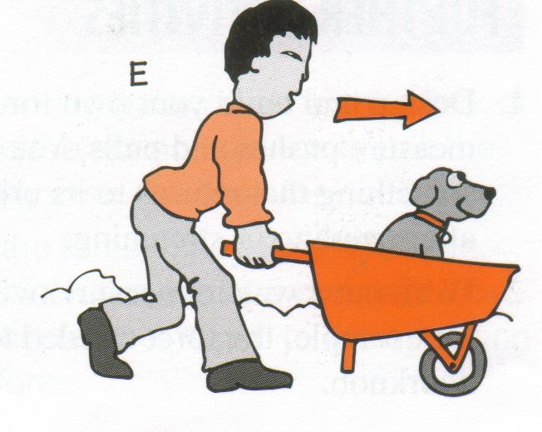

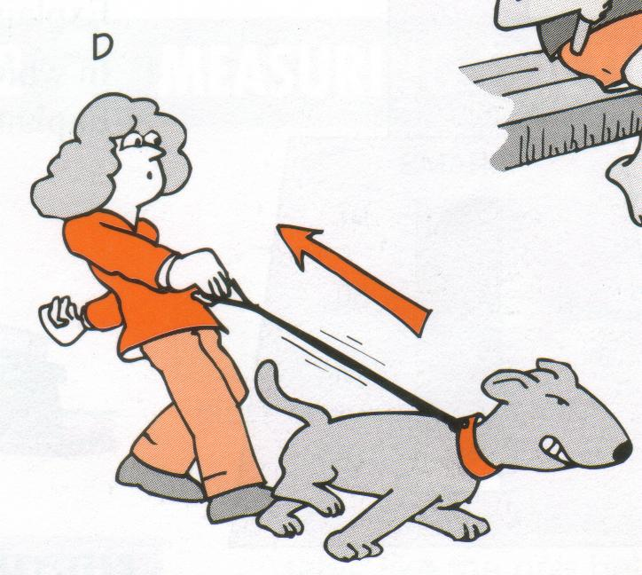

a.
b.
c.
d.
e.

Questions
- Sketch a person accelerating on a skateboard, and draw arrows representing the forces acting.

- Imagine you are falling down a cliff. What are the forces acting on you? Are they balanced?
Friction
Have you ever tried to help someone start a car by pushing it? It is very hard to get the car rolling right at the start. If you can get the car to move it seems to be easier to push once it has started to move. The car tyres have a force working against them. This force is trying to stop the car going forward or is said to be resisting the movement. This force is called friction.

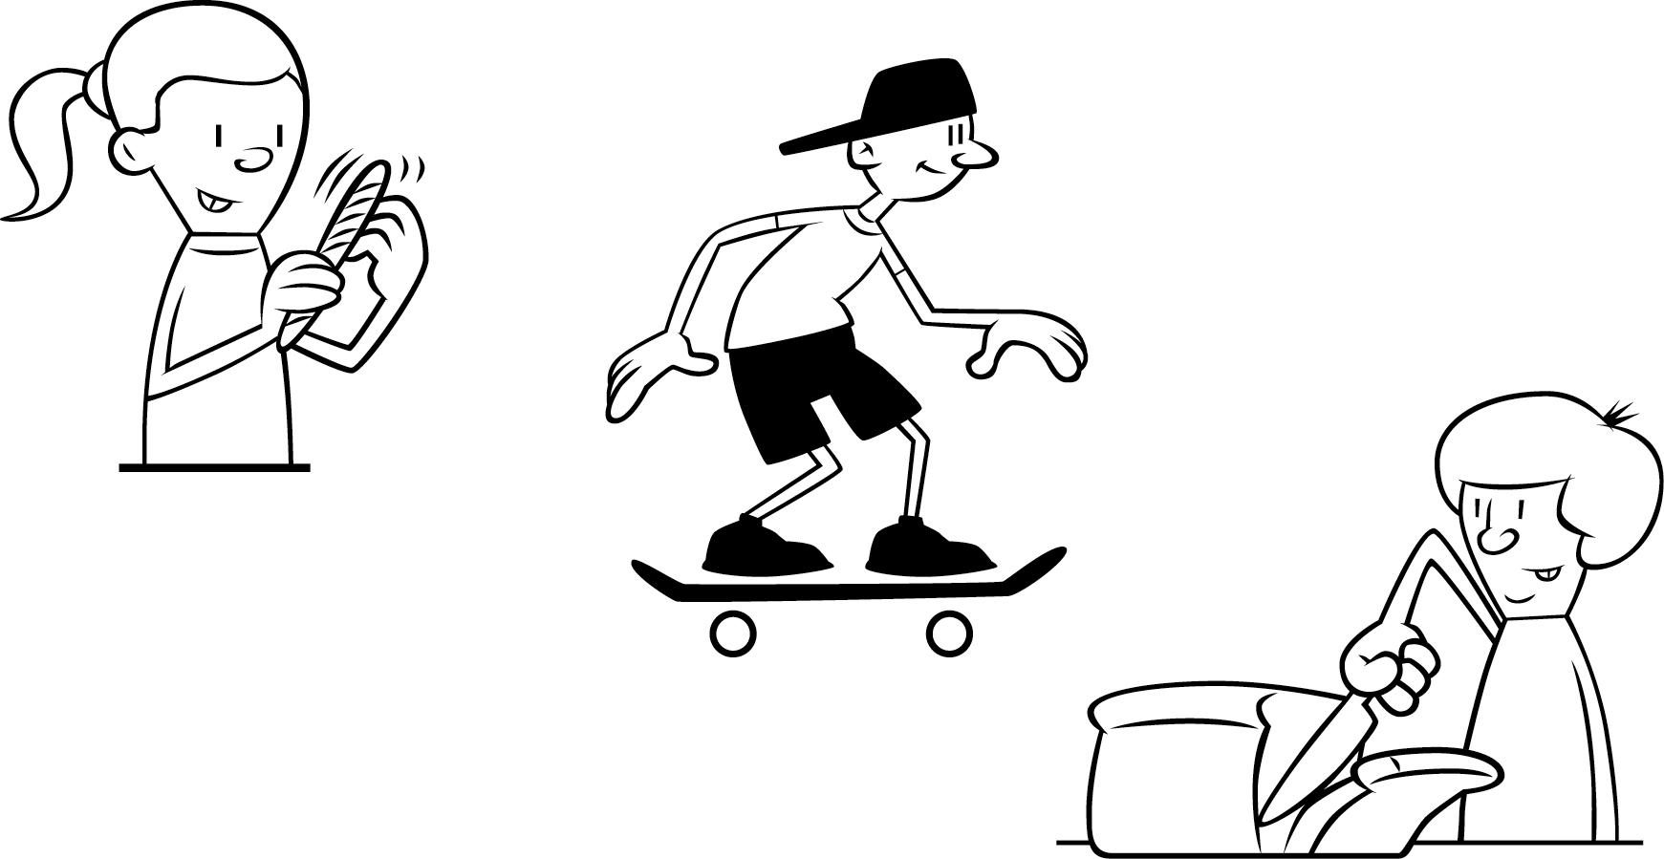
Friction is all around us. It is because of friction that erasers work for us. There is friction working against us when we ride a bike or skateboard, roller blade, run, play tennis, cut our food and use a nail file to shape our nails. These are just a few examples of friction at work.
There are several different types of friction:
• Static friction is the force that stops things from starting to move: think of trying to push a car.
• Sliding friction happens between moving surfaces such as in downhill skiing.
• Rolling friction happens when a curved surface rolls over another surface. This happens when the wheel of a bike turns in one direction and the bike moves in the other direction.
• Fluid friction happens between fluids or between fluids and solids. Fluid friction is less than friction between solids. Fluids are often used to help movement of two solids by reducing the friction between the surfaces. The axle on a bike has oil on it to help the metal axle turn more easily inside the casing.
Activity
Here are some pictures of different types of friction.
1 Label each picture static, sliding, rolling or fluid friction in the space.
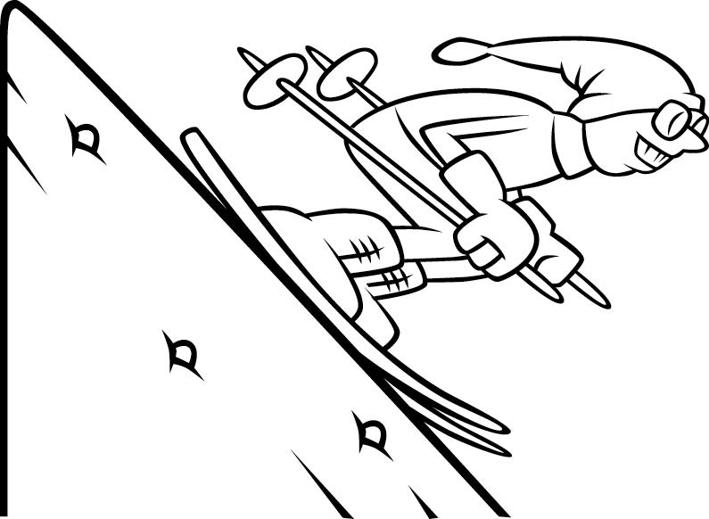
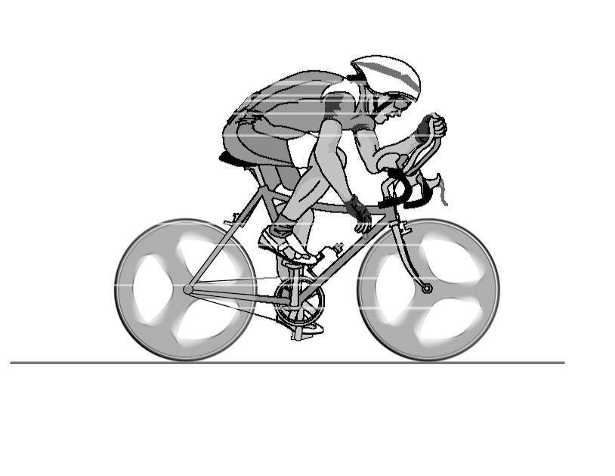
In the space provided write down why you think the example is static friction, sliding friction, rolling friction or fluid friction.

I think this is __________________ friction I think this is __________________ friction
because _____________________________ because _____________________________
____________________________________ ____________________________________
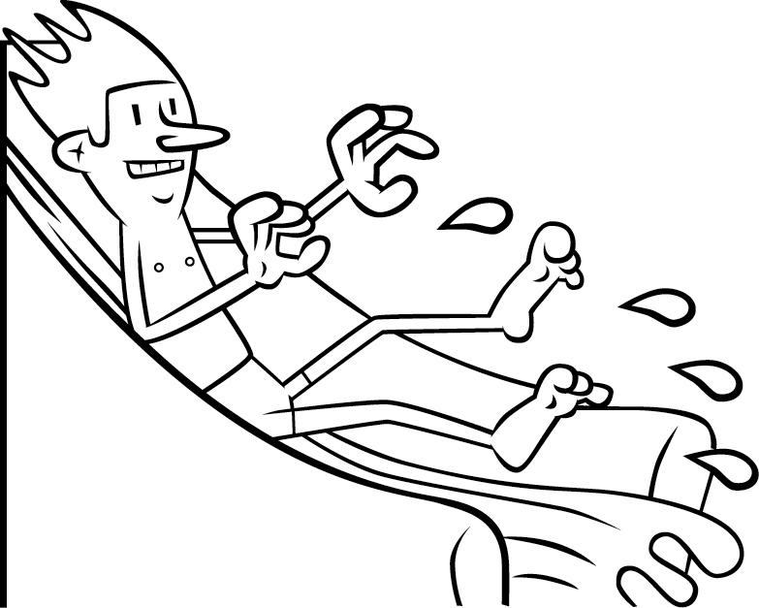
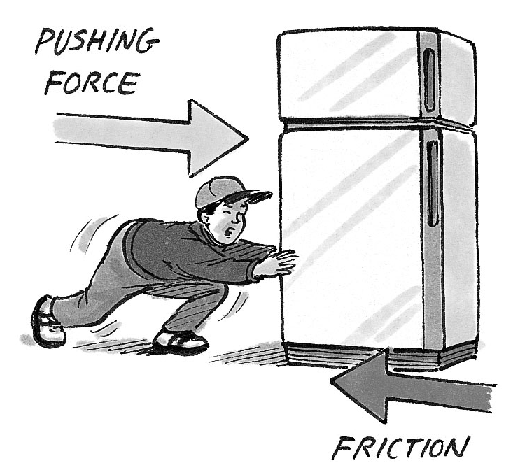

I think this is __________________ friction I think this is __________________ friction
because _____________________________ because _____________________________
____________________________________ ____________________________________
2 Think about this. Why is it sometimes very difficult to stop a car on a wet day?
Write down your answer in the space provided.
___________________________________________________________________________
___________________________________________________________________________
___________________________________________________________________________
___________________________________________________________________________
___________________________________________________________________________

Look at the following examples of ways in which we travel. List the forces that are acting in each case (gravity, friction, pushes, pulls, twists, etc.).

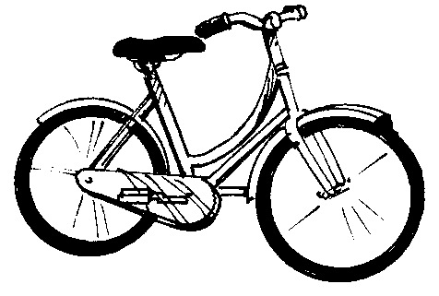 | 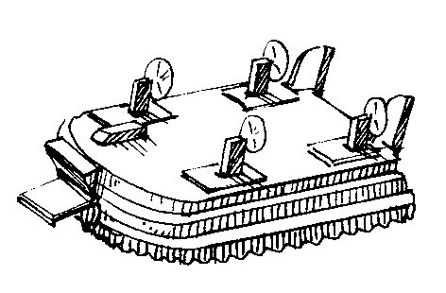
Bicycle | Hovercraft
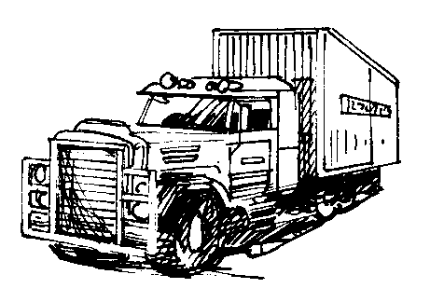 | 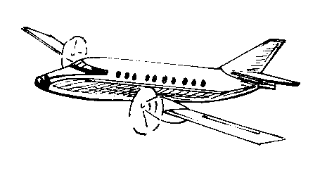
Truck | Plane
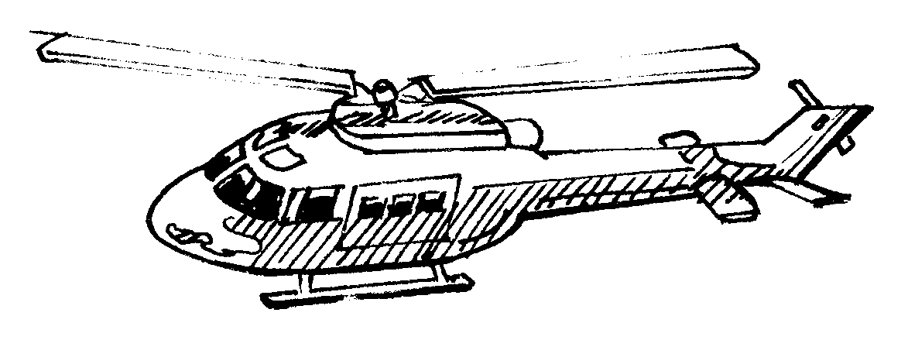 | 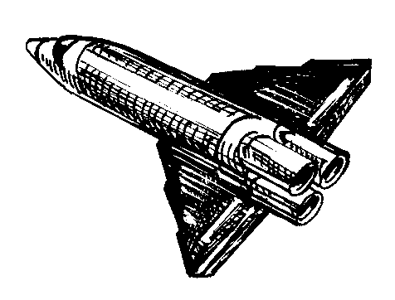
Helicopter | Rocket
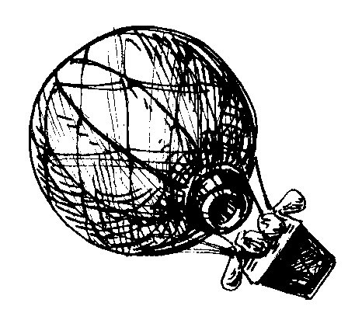 | 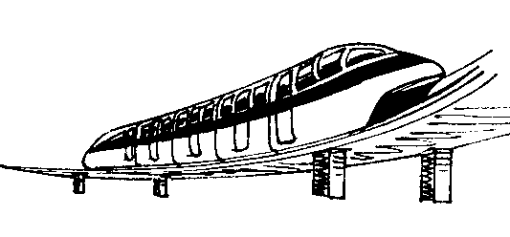
Hot air balloon | Monorail
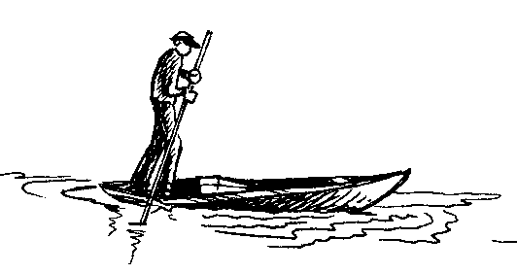 | 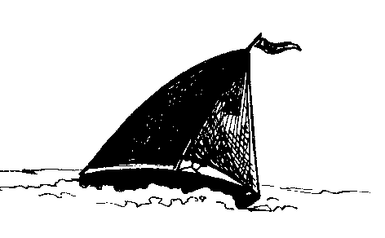
Punt | Yacht

The punt and the yacht both float on water and move forward. Describe the forces which act on these vessels when they are moving. How are they the same? How are they different?

1. A. Link the following examples to the appropriate forces
A compass Friction
Bungie jumping Magnetic

Sandpaper Gravitational
Sticky tape Adhesion
Water droplet Cohesion
Charged hair Electrical
Screwdriver Mechanical

B. From the above select contact and non contact forces

2. Complete the sentence
The effect of a force on a body is to change its____________ or its____________.

- Consider a car. Describe two ways in which this machine uses the forces of friction and two ways in which the force is reduced.

4. Answer the questions below from the following table:
Planet | Weight of brick (N) | Mass of Brick (kg)
Earth | 20 | 2
Jupiter | 50 | 2
Saturn | 25 | 2
Pluto | 3 | 2

a) On which planet was the weight of the brick the greatest?
b) On which planet was the weight of the brick the least?
c) Therefore which is the most massive planet?
d) On which planet was the mass of the brick the greatest?

5. An object is balanced on its edge such that part of it hangs over the edge of a table. If the object is stationary, what must be true about the system of forces acting on it? Give examples of the forces acting.

- Name the three types of non-contact forces?

QUESTION: Why don’t tourists go to the moon?

ANSWER: Because it doesn’t _ _ _ _ _ _ _ people like the earth.

To find the answers, first unscramble the seven words. There are clues besides each one to help you. Write the unscrambled words in the boxes, the shaded letters spell out the missing word in the answer to the question.

- This force helps keep us on the earth
T A I G V Y R
- This force slows down moving objects
I R N F O C T I

- This is a type of contact force
W S N I T G T I

- This thing causes changes
E R F C O

- This kind of force must touch an object before it can make something happen
N O T C T C A

- These provide the force needed to move the body
C E M U L S S

- This is a type of non-contact force
R E Y C E C T L I T I

Measuring weight and mass
If you put a one-kilogram bag of sugar on a set of scales, it is the gravitational pull on the sugar which forces the scale pan downwards-the scales respond to weight.
Some sets of scales are marked in newtons but most give a reading in mass units such as kilograms or grams (there are 1000 grams in each kilogram). Readings in mass units present no problem to manufacturers of scales because an object of large mass also has a large weight on Earth.
As for the one-kilogram bag of sugar: it has a moss of 1 kilogram and a weight on Earth of 9.8 newtons, but try telling them that at the supermarket!
Questions
- In what units are forces measured?

- In what units are masses measured?

- What is the common name for gravitational force?

- Why does an astronaut weigh less on the Moon than the Earth? How is his mass affected if he moves from the Earth to the Moon?

- How many grams are there in 1 kilogram?

- Why is it wrong to say that a bag of sugar 'weighs' 1 kilogram? What is the weight of the sugar on Earth?

- Use the conversion 1 kg wt = 9.8 newtons to complete the table.
MASS | WEIGHT
5 kg
48 kg
0.2 kg
0.85 kg
 | 30 N
 | 182 N
 | 7 N
250 g

- If a litre of water has a mass of 1 kg, how much water is needed top produce a force of gravity of
1. 20 N 2. 150 N 3. 1000 N 4. 4 N ?

Gravity

You can jump in the air but you cannot stay there. You are pulled down by the force of gravity. When you drop a glass or something falls, it is because gravity pulls the object towards the Earth. This gravitational force gives objects their weight.

Gravity is the pull of the enormous mass of the Earth on our bodies and any other objects near the Earth’s surface. It is a non-contact force since it is able to act over a distance, without the objects touching each other.

There is a small gravitational force that pulls any two objects together. The size of this force depends on:
- the masses of the objects, and
- how far apart they are.

Usually this force is very small, but when one of the objects is the planet Eart, the force is far from small. This law of gravitation was discovered by Sir Isaac Newton in the seventeenth century.

There is a gravitational pull between the Earth and the moon. This keeps the moon in place and causes tides on Earth. Similarly, a gravitational pull keeps satellites in orbit around the Earth. The Earth and other planets are kept in orbit around the sun by a gravitational pull.

Questions
- a) What two things control the size of the gravitational force between two objects?

- Why then is the force of gravity between two apples on a table too small to notice?

- Why is the force of gravity between the Earth and the star Rigel too small to notice?

- Why is the force of gravity between the sun and its planets strong enough to hold them in orbit?

- Suggest why the force of gravity is less on the moon?

Speed

Working out speeds!
Average speed = distance/time or average speed is the distance travelled in the time it took to go that distance.
Average speed has the symbol s. The symbol for distance is d and the symbol for time is t.
So average speed = 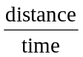 or s = 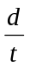
Let’s work out some speeds.
Jane rode her bike 40 kilometres in 2 hours. We want to know speed or s.
We know distance or d = 40 km. We know time or t = 2 h.
If s = then s = 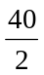 km/h
= 20 km/h
Always set out your calculations like this and you will find it easier to understand the facts that you have been given.
Activity
1 The distance from Coolangatta to Caloundra is 180 kilometres and it takes Marie 2 hours to make the trip. What is the average speed of Marie’s car in km/h? Write your calculation in the space below.
Use s = distance = 180 km time = 2 h

2 Joel walked 18 kilometres in 3 hours. What was his average speed in km/h? Set your calculations out like the example above.

3 Olympic runners can run 100 metres in about 9 seconds. What is their average speed in m/s?

A challenge!
4 If a Grand Prix car travels at 220 km/h, how long would it take it to travel 100 kilometres? Can you work this out? If you like you can work with a friend to solve this challenge.

Forces Crossword
 |  |  |  |  |  |  |  |  |  |  |  | ¹
² | ³ |  |  |  |  |  |  |  |  |  | ⁴
⁵
⁶ |  |  |  |  |  |  |  |  |  |  |  | ⁷
⁸ |  |  |  |  |  |  |  |  |  |  |  | ⁹
 | ¹⁰
 |  |  | ¹¹ |  |  |  |  |  |  |  | ¹²
¹³
 |  |  |  |  |  |  |  |  |  |  |  |  |  |  |  | ¹⁴
 |  |  |  |  |  |  |  |  |  |  | ¹⁵
 |  |  |  |  | ¹⁶ |  | ¹⁷
 |  |  |  | ¹⁸ |  |  |  |  |  |  |  |  |  | ¹⁹
 |  |  |  |  |  |  | ²⁰ |  |  |  |  |  |  |  |  | ²¹

  Across:
  2 | THE ABILITY AN OBJECT HAS TO RESIST MOTION
  4 | THIS FORCE PULLS US DOWN TOWARD THE CENTRE OF THE EARTH
  5 | THE MAXIMUM SPEED A FALLING OBJECT WILL TRAVEL TOWARDS THE EARTH
  6 | BUILDING AN ITEM IN THIS WAY REDUCES AIR RESISTANCE
  7 | AN OBJECT'S RESISTANCE TO CHANGES IN MOTION
  8 | THESE FORCES ONLY OCCUR WHEN TWO THINGS ARE TOUCHING
  9 | THE SI UNIT TO MEASURE FORCES
  10 | A FORCE EXERTED BY THE ATMOSPHERE TO SLOW THINGS DOWN
  13 | GETTING FASTER
  15 | THE FORCE THAT OCCURS WHEN YOU GLUE SOMETHING TOGETHER
  17 | THE FORCE EXERTED BY WATER
  18 | THIS FORCE SURROUNDS MAGNETS
  19 | A PUSH OR A PULL
  20 | HOW FAST SOMETHING IS MOVING
  21 | A SCIENTIFIC WORD FOR MOVEMENT
  Down:
  1 | THIS FORCE SLOWS US DOWN
  3 | A FORCE ON A CHARGED ROD OR COMB
  11 | THE TOTAL AMOUNT OF FORCES
  12 | FORCES ARE THIS WHEN AN OBJECT MOVES
  14 | THE SI UNIT FOR WEIGHT
  16 | ANOTHER NAME FOR FRICTION

